Crown Bank of Canada  
Written Status Report

**Team #6**

Elsie Umukoro [Project Sponsor]

Ramya Krishnasamy[Project Manager]

Kunj Shah [Business Analyst]

Shubham Kiritkumar Thanki [Data Analyst]

Neha Lingampally [Financial Representative]

Shravani Soujanya Kodam [Documentation Expert]

Shourya Sahni [Quality Analyst]

Table of Contents

1. Preliminary Results 3

2. Plans 4

3. Figures and Tables: 4

# 1. Preliminary Results

Present Situation of CBC

Growing Defaults: A notable increase in loan and mortgage default rates, especially for borrowers whose mortgage amounts exceed $400,000.

Operational Costs: With a cost-to-income ratio (CIR) of 62.1%, operating costs came to $73.788 billion, a 102% rise from the previous year.

Market Competition: Due to fierce competition from FinTech companies like Wealthsimple and EQ Bank, the market share fell from 37.1% to 36.4%, resulting in the loss of about 54,000 potential clients.

**Ideal Situation for CBC:**

Lower Loan Default Rates: Reduce loan and mortgage delinquency rates by improving risk management and customer service.

Optimized Operational Costs: Lower operating expenses to attain a CIR that is more competitive and either falls or approaches industry benchmarks.

Reclaimed Market Share: Grow your consumer base and market share, especially with younger audiences, by introducing innovative digital products and competitive pricing.

**Gap Analysis**

The difference between the intended and actual loan default rates is known as the risk management gap.

Operational Efficiency Gap: The difference between the actual and intended lower CIR for operations costs and efficiency.

Market Positioning Gap: The difference between the intended growth in market presence and client base and the present market share.

## 2. Plans

**Solution Strategy**

Enhancements to Risk Management: To lower default rates, apply advanced analytics to risk assessment and provide customized lending options.

Operational Cost Optimization: Streamline operations through process automation and efficient technology use, aiming to lower the CIR.

Digital Banking and Marketing: Enhance digital banking platforms and marketing strategies to attract younger demographics and compete with FinTech firms.

**Stakeholder Engagement and Approval**

Regular meetings with important stakeholders to go over progress and get input are part of the approval and stakeholder engagement plan.

A detailed presentation of the suggested solutions, together with their advantages and return on investment, is necessary to win over stakeholders.

### 3. Figures and Tables

|  |  |  |  |
| --- | --- | --- | --- |
| Metric | 2022 | 2023 | Change (%) |
| **Loan and Mortgage Delinquency Rates:** |  |  |  |
| Loans <$400,000 Default Rate | 0.45% | 0.47% | 4.44% |
| - Loans $400,000-$850,000 Default Rate | 0.75 | 0.80% | 6.67% |
| **Total Operational Costs** (In Billion CAD) | 36.5 | 73.788 | +102% |
| **CIR (Cost-to-Income Ratio)** | 60% | 62.1% | +3.5% |
| **Market Share** | 37.1% | 36.4% | -1.89% |
|  |  |  |  |

**Loss of Revenue due to increasing defaults:**

**Loss of Revenue due to operational cost:**

**Loss of Revenue due to market competition:**

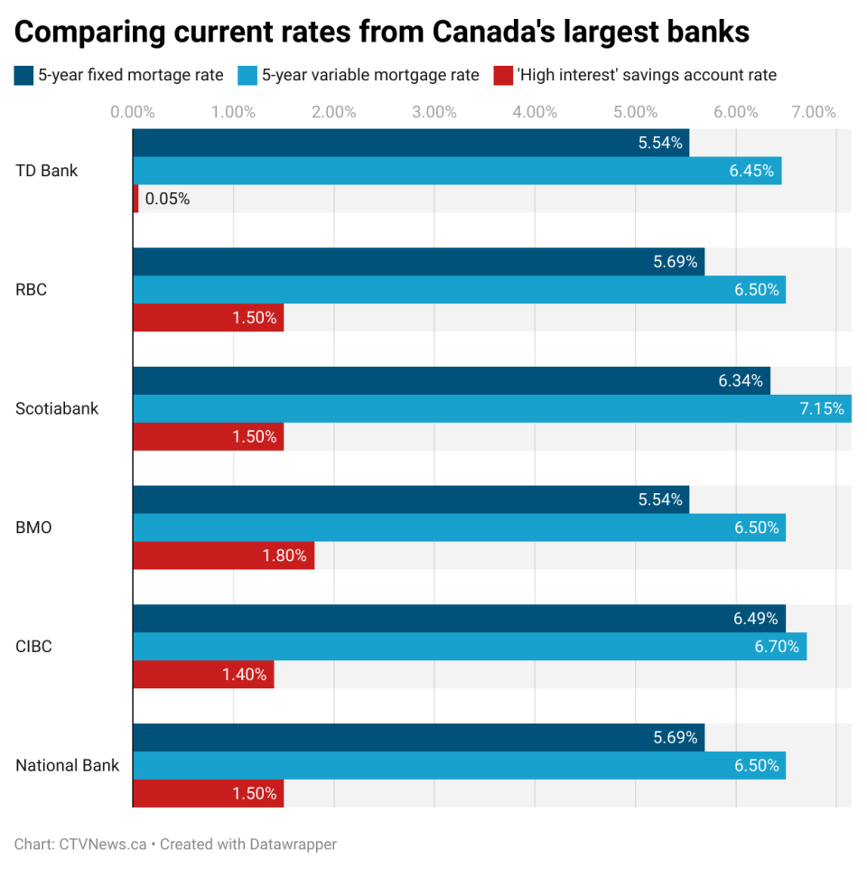

**References:**

<https://www.newswire.ca/news-releases/royal-bank-of-canada-reports-fourth-quarter-and-2023-results-859091176.html>

<https://www.theglobeandmail.com/business/article-rbc-earnings-fourth-quarter-results-2023/>

<https://www.statista.com/topics/5659/banking-industry-in-canada/#editorsPicks>